Pseudo code program 1:

1. Create a scanner to read input,
2. Declare all variables (double)
   1. double ta; //outside temperature
   2. double v; //speed in mph
   3. final double FIRST_COEFFICIENT = 35.74;
   4. double wcTemp;
3. Prompt user to enter temperature in Fahrenheit and windspeed.
4. Do input validation using a while loop to ensure value is in correct range
5. Enter user values in wind chill formula
6. Display wind chill temperature to sure for wind chill index

Pseudo code program 2:

1. Create a scanner to read input
2. Declare all variables(double)
   1. Distance
   2. Mpg
   3. Price
   4. Cost
3. Prompt user to enter distance, miles per gallon, price per gallon
4. Get user input and store variables
5. Print cost calculation through formula

Test Plan (validation) :

|  |  |  |  |  |
| --- | --- | --- | --- | --- |
| Cases | Input | Expected Output | Actual Output | Did Test Pass? |
| Case 1 | Enter a temperature in Fahrenheit between -58 F and 41 F: -59 | Please enter an integer in the correct range | Please enter an integer in the correct range | Y |
| Case 2 | Enter a wind speed (>=2) in miles per hour: | Please enter a number greater than 2: | Please enter a number greater than 2: | Y |
| Case 3 | Enter the driving distance: -10 | Please enter a value greater than 0 | Please enter a value greater than 0 | Y |
| Case 4 | Enter miles per gallon of vehicle: -20 | Please enter a positive value: | Please enter a positive value: | Y |

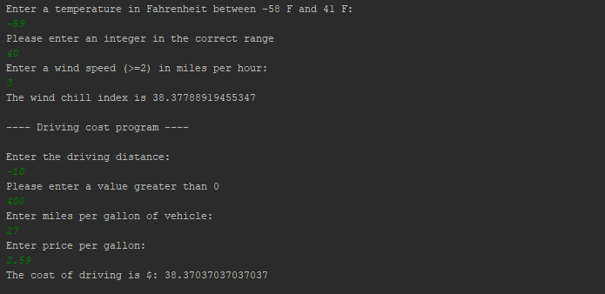

Program 1 & 2 screenshot output:

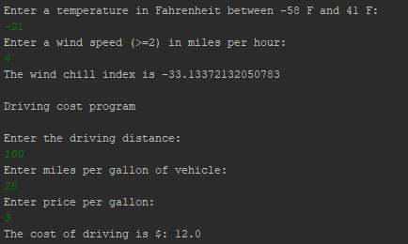

**Flow Chart**

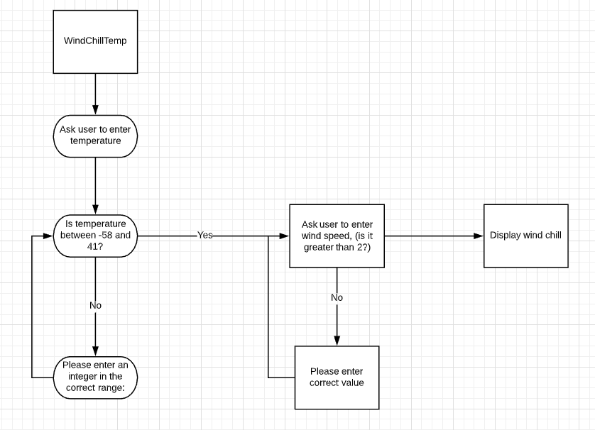

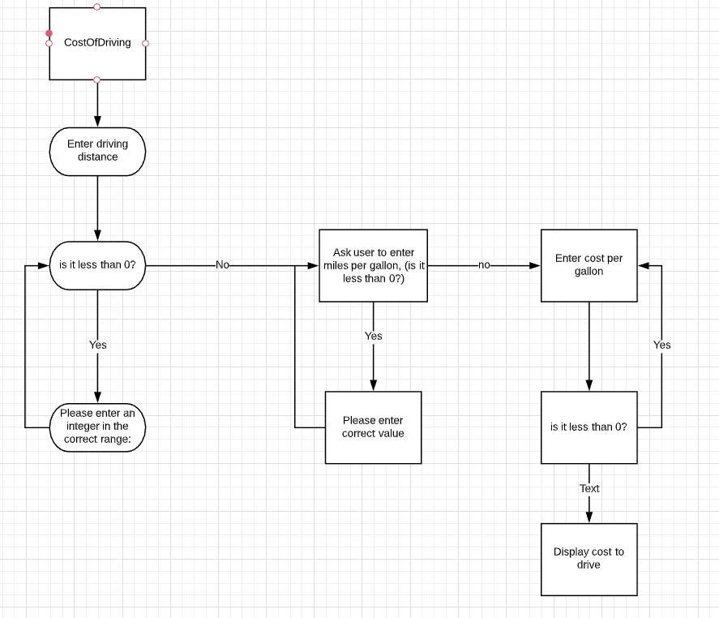

**UML class diagram**

|  |
| --- |
| **Class Name:**  **WindChillTemp** |
| **+ta: double**  **+v: double**  **+wcTemp: double** |
| **+WindChill(): void** |

|  |
| --- |
| **Class Name:**  **CostOfDriving** |
| **+distance: double**  **+mpg: double**  **+price: double**  +cost: double |
| **+DrivingCost ():void** |

Lessons Learned:

I learned to use the final keyword instead of const like you would in C++. I also learned to use the Math class in order to do exponents. There were some definite takeaways that I learned from this.